The History of Team CMU: Part 1
Nate Heiss
Team CMU has been an integral part of the Magic community for many years now and they have laid claim to fame time and time again as one of the most efficient and successful teams in the world. We have produced Magic celebrities and writers, as well as champions. This history of Team CMU is long overdue to be chronicled, and I hope it will serve as a true to life portrayal of one of the most prestigious teams in Magic history. I have spoken with members of the team, and their stories are recounted here along with my own experiences with CMU.
This article is a milestone for me in two respects. First, this will be my fiftieth feature article in my Magic writing career that has spanned three web sites and many pages. Second, this is my first article as a featured writer for the Sideboard. I would like to dedicate this milestone article to the people who breathed life into our team. Thank you guys. I would like to put in a special thanks to Del Laugel, who was vital to our success in so many ways, yet never received any credit for her efforts.
This account of Team CMU's history will be a three-part segment. The first part will cover the beginnings of Team CMU through Worlds of 1997, the second part will cover from Chicago or 1997 to Worlds of 1999, and the third part will cover from after Worlds 1999 until present day.

In The Beginning
The Cyert gang and the beginning:
When Team CMU was not even a thought in anyone's mind, Magic was something you played in-between the turns of longer and more complicated strategy games like Titan. In a little school building called Cyert Hall, people like Erik Lauer, Andrew Cuneo, Elliot Fung, Chris Esko, Josh Brody, and Abortion Pete (He was always called this due to the anti-abortion pin he wore to tournaments) spent their spare time leisurely playing these games while tinkering with the cute new card game on the market. It turned out to be more fun then they initially thought it would be, and the game quickly became a standard game to play at Cyert Hall on CMU (Carnegie Mellon University) campus.
Two Headed Giant:
A local store was holding a Two Headed Giant tourney one fateful day when a team composed of two helpless newbies (Randy Buehler and Del Laugel) was pitted against the wits of Erik Lauer and Abortion Pete. Randy played a Stormdrain deck while his partner, Del played a deck whose entire purpose was to cast Counterspell, ensuring Randy's combo would go off without a hitch. Erik and Pete both were playing Mana Crypt combo decks complimented by the power nine. Afterwards, Randy and Erik discovered they were both going to attend the same qualifier, and decided to test together for the tournament.
These players attended many tournaments, including the first North American GP, GPDC. Esko and Lauer qualified for Dallas, Esko played a U/R deck there, while Lauer played Necro. Esko pulled out 22nd place and Lauer finished in 47th. After this, Esko moved away to DC and Randy started having headaches trying to qualify with Sandsipoise. Cuneo ended up qualifying for Paris and took a trip there, ending up at 73rd. Shortly after this he moved away and played for a while with Tongo and similar teams, eventually creating the famed Cuneo Blue deck type.
The Silberfactor:
During one of Randy's travels to various qualifiers, he found himself at Origins, held in Columbus, Ohio. While in between rounds, he ran into a Cincinnati native by the name of Dan Silberman. Dan said he was going to CMU in the fall. Randy invited him to play Magic at Cyert with everyone else, figuring they needed all the help they could get.
A Couple of Cousins:
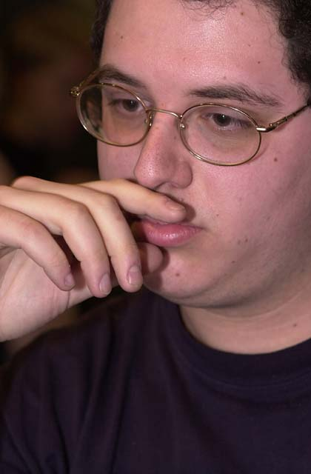
Mike Turian
At the time, Michael Turian was about to leave his high school years behind and enroll in CMU. He bumped into a guy named Randy Buehler at one of the numerous tournaments held at the Dungeon, a local store. They were playing in the finals for a Black Lotus, and ended up splitting. Randy told Mike about the Magic group at Cyert Hall. Mike said he would probably come and test with them because he had qualified for Pro Tour Chicago recently with his W/G Mistmoon Griffin deck. Randy said he was still trying to qualify for Chicago after numerous, mind wracking attempts, but they would be practicing the Extended format for the Pro Tour.
Mike had a cousin that he taught to play Magic, and decided to bring him along to play testing sessions at CMU. That cousin was none other then myself. I was not qualified for anything, and couldn't go to the Pro Tour at any rate because it fell on the same weekend as Yom Kipper. At the time I was living at home, where my Orthodox father forbade me to go. However, at the time I was very addicted to Magic, playing anytime and anywhere. I was just getting my drivers license that year, and now I had somewhere to drive to, Cyert Hall.

Oh, Canada!
After the first semester came to a start at CMU in 97', Randy, Erik, Mike, and Dan took a trek up to our strange and mysterious neighbor, Canada, to play in the illustrious GP Toronto. As it turned out, not a whole lot of people showed up for Toronto, and even less of them were good players. In fact, there was only one other group of high quality Magic players floating around the room, those of the team called Deadguy.
The Top 8 contained 3 out 4 of a rag-tag group of people who went to CMU. Naturally Deadguy started to converse with the gang, and eventually Tony Tsai said something along the lines of, "You guys should be called Team CMU," referring to the CMU hat that Randy wore (even though he was actually attending Graduate school at Pitt during that time). From that point and thenceforth, we were known as Team CMU. Erik qualified for Chicago at the Toronto top eight, with Mike, and Dan passing down the slots and picking up the prizes in the Top 8. Randy convinced them to make a team split and ended up being a well-paid chauffer. That tournament set the stage for the original four members of team CMU.

Let There Be Team!
When Team CMU returned from Toronto, three Magic classes were inadvertently formed in Pittsburgh. Team CMU was the first class, including those people on the CMU Prize split; comprised of some crazy yet fair equation Lauer came up with (to this day, I still don't remember all the details of how it actually worked). That class included only Randy, Erik, Mike, and Dan.

The second class of Magic players was lovingly known as the 'Friends-of-CMU.' This was a larger class of players, extending to those people who play tested with Team CMU and those people who did not go to Toronto. The second class included Andrew Cuneo, Elliot Fung, Abortion Pete, Josh Brody, and myself. This class expanded and shrunk as time went along, and is updated periodically throughout the article. Every time someone became a 'Friend-of-CMU' or was added to the actual Team CMU roster, it was a pretty big deal and showed up in various places on the net.
The third class of players was anyone else left in Pittsburgh who played Magic. Granted, this was quite a lot of people, but the Magic community was as important as ever in the development of Team CMU. All the Magic players in the southwestern PA area played a vital role in field testing decks and keeping tech secrets from leaking out into the world. It was because of these people that we were not afraid to test Pro Tour decks in local tourneys. We knew that it would not be plastered on the net by these great folk.

Chicago
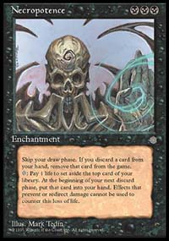
Extended ran through everyone's mind in the fall of 1997. The newly formed Team CMU struggled through the mysteries of play testing at Cyert hall. At the time, play testing was still in somewhat of an artistic stage of development, and would not be broken down into a science for at least another year to come.
Everyone was happy because of the successes in testing, and everyone loved playing Magic. In testing, the deck with the strongest showing was Lauer-Potence. Of course, at the time, everyone simply called it Firestorm Necro or Necro-Fire. This version was preferred mostly because of the utility that Disenchant gave the deck, being that the Land Tax deck was another popular choice in Chicago. Erik decided not to play his own deck in order to give the team some balance, and chose Counter-Post as his deck instead.
Lauer-Potence
PT Chicago 1997
Main Deck |  | Sideboard
3 Lake of the Dead  2 Bad River  4 Badlands  4 Scrubland  3 Gemstone Mine  8 Swamp  4 Knight of Stronghold  4 Order of Ebon Hand  1 Ihsan's Shade | 4 Lightning Bolt  2 Incinerate  2 Firestorm  3 Disenchant  4 Demonic Consultation  4 Necropotence  4 Drain Life  4 Hymn to Tourach | 2 CoP: Black  3 Honorable Passage  1 Disenchant  3 Pyroblast  2 Mind Warp  3 Terror  1 Firestorm
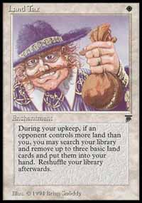
While on the way to the PT, Mike was still undecided about his deck. While in the car, Erik built a W/R deck and gave it to Mike. The deck consisted of Land Taxes, Phyrexian War Beasts, Savannah Lions, Bolts, Fireballs, and the original CMU tech, Stone Rain. The team discussed the deck over much of the distance to Chicago, tuning it to a theoretical powerhouse. After they arrived, Mike built the deck and dubbed it the 'In The Car Deck,' being as it was built in the car. Later, people started referring to it as the Indy Car Deck, with reference to the racing cars. After Mike pondered this for a while, he decided that the deck was probably made while driving through Indy, so that was fine with him. He amazed everyone by making Day 2 with the deck at a comfortable margin. He went on to make Top 32 in Chicago, a very respectable performance for a first Pro Tour.
Randy was the only other team member to make Day 2, with a less comfortable margin. However, once Randy started his matches on that second day, he literally plowed through the field, leaving a wake of startled players in his path. He went on to steal the top prize riveting the Magic community with an underdog victory. This act alone bought Team CMU instant respect and prestige in the Magic community, which is something the team was desperately looking for. Team CMU was no longer a rag-tag bunch of Pittsburgh players; they were something to be feared.
After the PT, everyone was a bit shocked and amazed. None of Team CMU ever expected to do so well on their first time out. I think everyone knew that something big was going to come of it, and we worked really hard from then on.

Mainz-Mania
After Chicago, the next PT stop was Mainz. It was a Rath Cycle Booster Draft format (Tempest/Stronghold), and it was fairly new. Randy and Mike were qualified based on their performance in Chicago, and Erik qualified via the PTQ system, but decided not to go at the last minute (using laundry as an excuse!). Ron Kotwica, a local player, qualified through the PTQ system and started drafting with us as well, becoming a new Friend-of-CMU
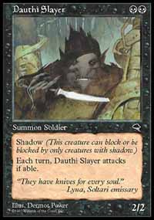
We playtested hard for Mainz, newly invigorated by two successes. We would do about five drafts a week, if not more, all in the comfort of Cyert Hall. Everyone liked to draft Black and Red, taking shadow guys in Black alongside giants and burn from Red. Mike liked Green/Black and White/Black, mainly due to the fact White and Green were under-drafted. Randy kept dwelling on a fairly moot discussion about how he should pass Trained Armadon if it came to him fourteenth, that way the person next to him might go Green. Besides that, the three brave Pittsburghers flew to Germany.
While in Germany, an interesting fellow by the name of Gary Wise asked Mike to draft, saying that he had heard of Mike from his high finishes at Toronto and Chicago. Gary and Mike immediately became friends, and discussed draft strategies, including a vital tip to Mike that Overrun was a good card. When all was said and done, Mike finished 11th, Ron finished 14th, and Randy finished 39th. It only was Team CMU's second Pro Tour, but they finished like they had been Pro's all their lives.

Two Grand Prix and PTLA
When the PTQ season for LA rolled around after Mainz, I was still fiddling with the notion of which deck I wanted to play. The unqualified group of CMU was Dan Silberman, Elliot Fung, Erik Lauer, and myself. For the first two PTQs I played in, I decided to use Lauer-Potence, beginning a long history of bad Consults and playing incorrectly. Eventually I got fed up with Lauer-Potence and started looking for a new deck.
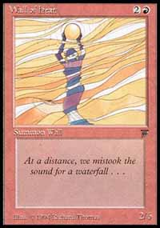
Elliot had the most interesting deck to me; it was a strange combination of cards that usually left him with a Wall of Heat sitting on the board and a Serra Angel beating on his opponent. It was good, but missing something. He said he was working on a second version of the deck, but he still liked his first one better. I took a look at his second version and decided to put some time into making it work right.
Dan Silberman and I both qualified at the 2-slot PTQ at the 3-rivers Gamefest of that year. I wanted to play a straight black Necro-Sengir deck that Dan made and Erik modified only a few days before. It was thrashing just about everything we threw at it. He said he was going to play in the tourney as well, and we could only make one copy of the deck. I said ok, and went to put the finishing touches on my other choice; the W/U/R beast that pulled in six different directions, yet still came together.
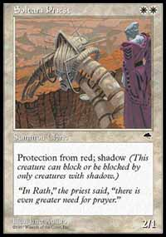
Erik did not show up for the qualifier that day, but Dan walked in toting the deck I wanted to get from him. Apparently Dan was with Erik when he decided not to come, so Dan decided to play the deck since it was so good. We both made Top 8, wading through a field full of White Weenie, Jank, and Sligh. Dan had it easy with the Necro deck, but I was forced to play against a particularly difficult opponent also playing a Necro deck similar to Lauer's. The two main differences were that this version had Icequakes and that the pilot was none other then Brian Schneider, of Tongo Nation fame. Lady Luck was with me that day, and every time he Hymned me, I Tithed. Every time he dropped a Sengir, I had Control Magic, and every time he Consulted, the demon did him in. It went the same way for him again when I played him in the semifinals. Mine was probably the only deck in history to qualify while using Wall of Heat, Soltari Priest, and Control Magic at the same time (or Wall of Heat alone, for that matter).
We took two trips to GPs that season, one to Atlanta and one to Indy, both of them to qualify for NY (Urza's Saga draft). At that time, Cuneo had moved to D.C. in order to take on a job and have somewhat of a normal life. On our trip down to Atlanta, Randy, Erik, Ron Kotwica, Scott Teamman, Jake Hillman, and myself drove down to D.C., stayed a night at Cuneo's, and headed down to Atlanta with Cuneo on board. He expressed that his job was mighty boring to him.
At Atlanta, Ron, Randy, and Scott made Day 2. However, Scott failed to show up in time for his first draft, which set the tone for the rest of his day. Randy went on to win the whole thing and Ron ended up with a passed down slot. Other notes about Atlanta included a rare Richard Kane Ferguson card signing (I have never seen him at a signing since), and my first encounter with Mike Long, who was boasting about some shady things he did in front of a crowd.
The same group of people took the trek to Indy, plus Mike Turian, Jean-Luc Park, Mike Byrne, and Aaron Forsythe. All I remember about Indy is opening up a Cursed Scroll and going 0-2 drop. That was a disappointment, and I played in a PTQ the next day (incidentally my first meeting with Zvi. I am 1-0 versus him lifetime) and made top eight while cheering on Randy, hoping that he would pull out another GP win. He came in 5th, and that was a pretty good record so far...winning 1 PT, 1 GP, and making a GP T8. He ended coming in 5th again in GP Antwerp after struggling over the decision to buy a plane ticket.
During this time, we started out testing for LA. We all got affiliated with Brian Schneider more during this time, and he joined the team. We decided to work with him in order to create the best deck in Rath Block Constructed via rigorous play testing (Brian did his testing from afar, for the most part). Erik and Randy deserve a lot of the credit for the LA testing. We went through many different incarnations of many different decks (Including a Capsize/Thalakos Seer deck, with a spattering of Tradewinds) until we stumbled onto the golden find of the set, Ancient Tomb. At this point, Brian was made an official Team CMU member, which caused some ruckus in the Magic world.
We made two excellent decks off of the Ancient Tomb concept, Ancient Red and Iron City Beat-Down. Ancient City Red was a deck very similar to Dave Price's winning deck, sporting the techy Giant Strengths and all. We had a strong feeling that COP: Red was going to be a popular card at LA, so we decided to go with Iron City Beat-down. Iron City Beat-down was originally a Sliver deck built by Mike, and then it was reworked into a meta-gamed lean, green, beat-down machine. Horned Sliver and Rootwalla were definitely MVPs here...
Iron City Beat-Down
PTLA 1998
Main Deck |  | Sideboard
4 Wasteland  3 Ancient Tomb  19 Forest  4 Metallic Sliver  4 Skyshroud Ranger  4 Muscle Sliver  3 Trained Armadon  4 Rootwalla  3 Horned Sliver | 4 Cursed Scroll  4 Elvish Fury  4 Winters Grasp
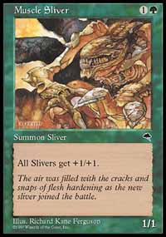
It turns out that everyone played Warmth over COP: Red for some god-awful reason, and Ancient Red would have been a better choice, but Iron City Beat-Down placed 5 out of 5 people in Day 2, two of which (Randy and Brian) made Top 16. An interesting fact about PT-Slivers was that all of the CMU members played at least one other CMU member in the tournament. I guess those Slivers like to pair up!

New York, New York...
After another great performance, CMU was pumped and ready to go. Only two of us were qualified for NY, Randy and Brian. However, after a grueling qualifier season, Erik ended up qualifying through the PTQ system or on Ratings (I can't remember which), Mike qualified through a PTQ which he cleverly beat Rich Frangiosa in the finals, and Dan also edged out a qualifier.
We invited more people to come and test with us, including Brian Schneider, Gary Wise, and the good local players. Ron Kotwica also tested with us since he qualified at Atlanta. At one point, most of the team took a trip up to Ithaca in order to test with the Deadguys.
After a full testing period, Randy and Erik liked drafting R/U for it's Tempo, Mike and Dan liked W/R for its crazy combos, such as Hero's Resolve on a Flowstone guy. They took their playtest knowledge up to NY, but alas, a tradition of doing poorly or sub-par started at this Pro Tour. Henceforth, at every PTNY (excluding team Pro Tours) Team CMU would do badly. Buehler finished 41, Lauer finished 46, Turian close behind at 47, and Silberman in the 90's.

CMU goes to Nationals 97'
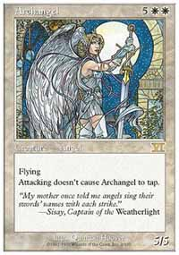
After New York, the Pro Tour season was basically over, and all that remained was Nationals and Worlds. Needless to say, CMU once again stepped up to redefine the environment. While testing for Nationals, we (read: mostly Erik Lauer) came up with the infamous Oath of Druids/Archangel Deck. This is the deck that used Oath of Druids to soft lock the game, then go to town with a Scroll Rack/Mulch engine, backed with Gerrard's Wisdom. Randy took the deck to a perfect record in the Constructed part of the tourney. Dan also showed up and played the deck, after taking a crash course in it (he had gone home for the summer and had not played Magic in a month), and ended up finishing in the 40's. Erik and Mike decided to play Sligh, and Erik ended up losing to Finkel in a match to make top 8, his Sligh pitted against Forbidian.

Turbo Mulch
Randy Buehler - 1998 US Nationals
Main Deck |  | Sideboard
7 Forest  7 Plains  4 Grassland  4 Brushland  2 Quicksand  2 Wasteland  2 Archangel | 4 Oath of Druids  4 Wrath of God  3 Gerrard's Wisdom  2 Cataclysm  4 Scroll Rack  2 Disenchant  1 Aura of Silence  2 Creeping Mold  2 Enlightened Tutor  4 Gaea's Blessing  4 Mulch | 2 Jester's Cap  2 Armageddon  4 Abeyance  1 CoP: Red  1 Gerrard's Wisdom  1 Elephant Grass  1 Choke  1 Emerald Charm  2 Disenchant
This was also the first Origins where Team CMU entered the Duelist Team Championship (now the Sideboard Team Challenge), a 5 man/5 player format where each team assigns one of its five team members to a format, and that player plays heads up against each of the opposing teams assigned player for that format. The CMU team consisted of Randy, Erik, Mike, Dan, and Cuneo. Needless to say, they won the whole thing.

CMU Goes to Worlds!
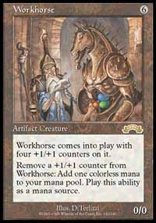
World 97 was held in Seattle, and three of our crew were heading our there. Randy, Mike, and Erik were all qualified and planned to play test very hard in order to keep the gold flowing. Through our testing, we discovered a lot about the new Rath Block Constructed Format, which had recently benefited from the extremely powerful Exodus set. We had a lot of great decks, but a few stood out and shined.
The first deck was the infamous HorseCraft deck, which made a surprise attack on the Worlds field. It killed using a Recurring Nightmare/Earthcraft/Workhorse/Overgrowth combo that could also use Corpse Dance or Survival of the Fittest to set it off. It was a complicated deck, but worked nonetheless.

Horse-Craft
Main Deck |  | Sideboard
12 Forest  10 Swamp  2 Workhorse  2 Spike Feeder  2 Mindless Automaton  1 Hermit Druid  1 Mogg Fanatic  1 Spike Breeder  3 Spike Weaver  4 Wall of Blossoms  1 Stronghold Assassin | 4 Earthcraft  4 Overgrowth  4 Recurring Nightmare  3 Corpse Dance  3 Survival of the Fittest  3 Scroll Rack
The next great deck was, in my opinion, Erik Lauer's most masterful creation, Counter-Phoenix. He discovered the deck close to the time when Worlds was going to occur, but decided to play it even though it was only tested minimally. This deck used the power of Shard Phoenix and Whispers of the Muse to dominate the game on every front. It was a truly great deck that Randy used to dominate many Grand Prix later on.
Counter Phoenix
Erik Lauer - Worlds 1998
Main Deck |  | Sideboard
14 Island  10 Mountain  4 Reflecting Pool  1 Caldera Lake  4 Shard Phoenix  1 Mogg Fanatic | 4 Intuition  4 Mana leak  4 Counterspell  4 Forbid  2 Dismiss  4 Shock  3 Capsize  1 Scroll Rack | 3 Mogg Fanatic  3 Portcullis  3 Thalakos Drifters  3 Shattering Pulse  1 Dismiss  2 Stalking Stones
The third deck was the infamous CMU Blue deck that Team CMU and Gary Wise played at worlds (sometimes called Draw-Go, because that's all it did). The deck took it's time, dealing with every threat that hit the table in due turn. Eventually, when you had a ton of mana backing you up, you would activate a Stalking Stone or cast Rainbow Efreet for the kill.
CMU Blue
Gary Wise - Worlds 1998
Main Deck |  | Sideboard
4 Stalking Stones  4 Quicksand  18 Island  1 Rainbow Efreet | 4 Whispers of the Muse  4 Impulse  4 Nevinyrral's Disk  4 Dismiss  2 Dissipate  3 Forbid  1 Memory Lapse  3 Mana Leak  4 Counterspell  4 Force Spike | 1 Grindstone  2 Capsize  4 Sea Sprite  4 Hydroblast  4 Wasteland
The fourth deck was a little deck that I was fooling around with that I was evolving from our old mono-blue Tradewind deck from the PT-Sliver gauntlet. I tweaked it and tested it, and got it to a point where it was beating everything in our Worlds gauntlet. Everybody chuckled at it and laughed it off, saying that no one would ever use such a deck. Why? Because I played with Manakins...and they were good. This was the deck I used to qualify for Rome, which I dubbed Turbo-Tradewind but was dubbed by others "The Mawcor Deck." More on this later...
Randy had the best showing at Worlds that year, finishing 12th. Erik was net up at 35, and then Turian at 66. I think it was the Limited portion that got us that year, but we had a great run in the Rath Block and Type 2 Portions. It was truly a Worlds not to forget.

The Road to the Future
That was a brief recap of the events CMU took place in during the 1997-1998 Pro Tour season. In the second installation of this history, I will cover the following season and all the mishaps and victories that came with it. If you have any specific questions about the history of Team CMU or any other questions in general, please feel free to email me at nateheiss@yahoo.com. I will answer them the best I can.

